C++ ASSIGNMENT 1

Q1.

#include<iostream>

using namespace std;

int main() {

cout<<"Physics"<<endl;

cout<<"Wallah";

return 0;

}

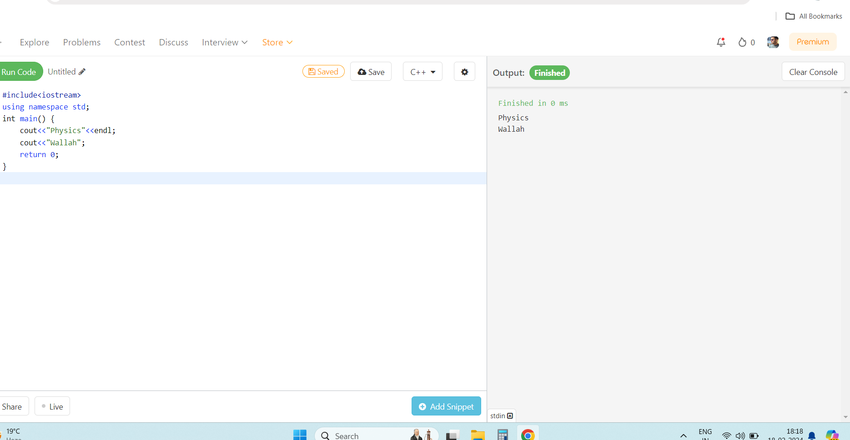

Q2

#include<iostream>

using namespace std;

int main() {

int n1=5,n2=5;

cout<<n1+n2;

}

}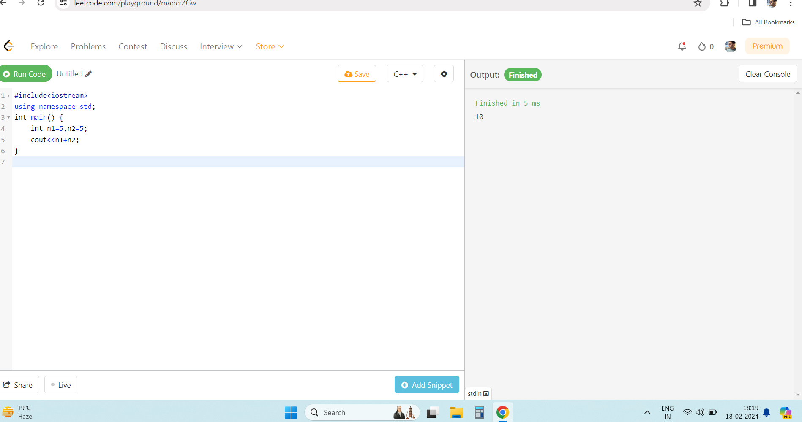

Q3

Int and float takes 4 bytes and bool 1 bytes.

Q4

Output is 6 4

Q5

#include<iostream>

using namespace std;

int main() {

int radius=10;

float circum;

circum=2*3.14*radius;

cout<<"Circumference of a circle is : "<<circum;

return 0;

}

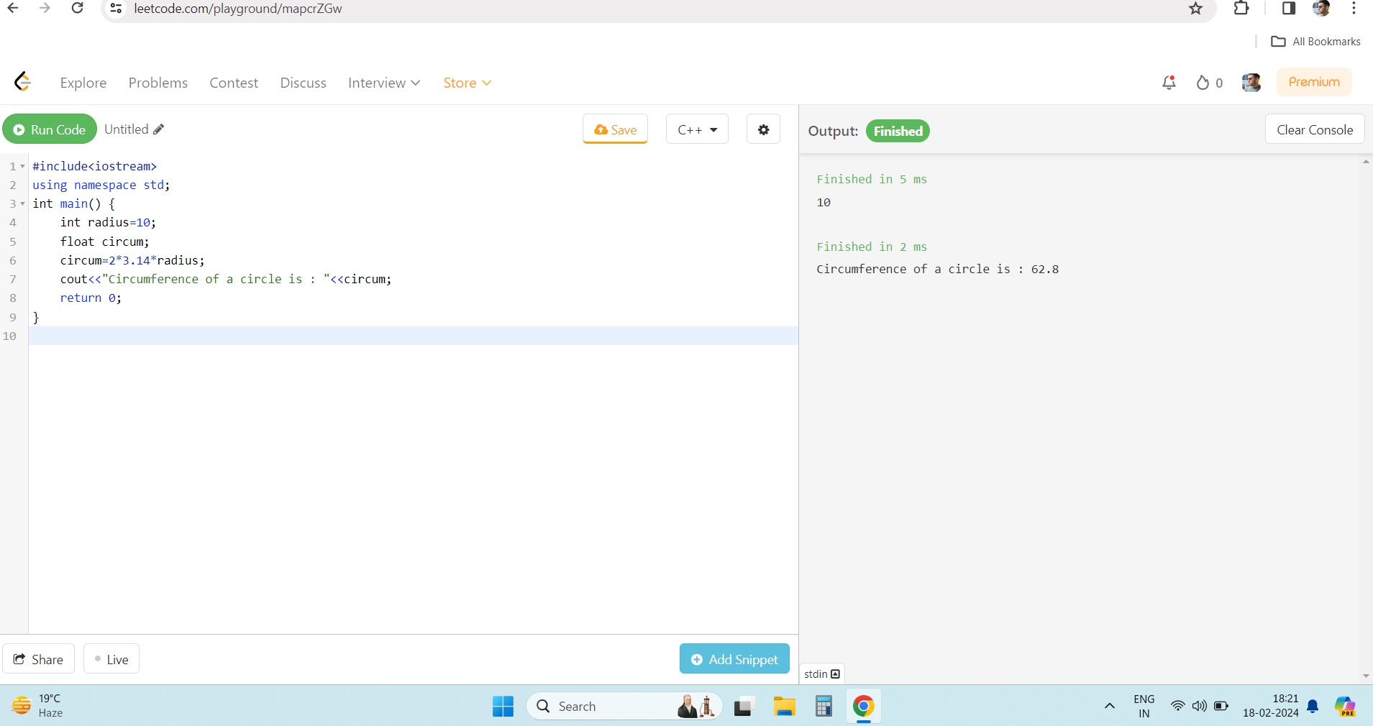

Q6

Valid variables are:

_FLOAT

FLOAT